APA Assembly Notes
April 2020
This digest of events during the April virtual Assembly meetings held via Zoom summarizes the business conducted by the Assembly.

Speaker’s Welcome — Paul O’Leary, MD
Dr. O’Leary welcomed all to the April virtual meeting of the Assembly. He discussed the tremendous effort put into organizing and orchestrating the format for the meeting, which is scheduled to run for 1½ hours today, rather than the usual 2½ days of meetings in person, as has been the tradition of the APA Assembly. However, circumstances involving the coronavirus COVID-19 have precluded the conducting of business as usual. In addition, many of us are all too aware of the toll this pandemic has taken on colleagues around the country. For them, Dr. O’Leary asked for a moment of silence.

Report of the Rules Committee — James R. Batterson, MD
Ordinarily, the Rules Committee report would not receive comment in the Notes. However, with recent changes in the Procedures Code of the Assembly, the Rules Committee was tasked with new responsibilities. In addition to the assignment of Action Papers and other actionable items before the Assembly either to the Reference Committee or to the Consent Calendar, the Rules Committee also assigned some Action Papers to a Reaffirmation Consent Calendar. In addition, because of the unique circumstances of this Virtual Meeting of the Assembly, a third assignment category option was to defer those Action Papers and other actionable business not considered time sensitive to the November Assembly Meeting, when they might receive more deliberative attention. Also, several authors volunteered to defer their Action Papers until November as well. The results of those action items on which the Assembly decided can be found below. Special Rules of the Assembly for this virtual format were also approved by the Assembly.

Assembly Election Results — James R. Batterson, MD, chair Assembly Nominating Committee
Results of last week’s election of Assembly officers were announced. For Speaker-Elect, Mary Jo Fitz-Gerald, MD (Area 5) was elected by acclamation. For Recorder, Adam Nelson, MD (Area 6) was elected. Congratulations to the new officers and to all the candidates on a hard fought campaign.

APA Position Statements
The following Position Statements were approved by the Assembly: (by consent)
Retired Position Statement: Endorsement of the Patient Physician Covenant
Proposed Position Statement: Use of Antipsychotic Medication in Patients with Major Neurocognitive Disorder (MNCD)
Proposed Position Statement: Universal Health Care in the United States
Revised Position Statement: Banning of Pharmacy Benefit Management Policies that Require the Provision of Dangerous Quantities of Medications
Proposed Position Statement: Mental Health Needs of Undocumented Immigrants
Proposed Position Statement: Competence Evaluation and Restoration Services and the Interface with Criminal Justice and Mental Health Systems
Proposed Position Statement: Pharmaceutical Marketing to Justice Entities regarding Medication Treatment for Substance Use Disorders
Retired Position Statement: Death Sentences for Persons with Dementia or Traumatic Brain Injury
Retired Position Statement: Diminished Responsibility in Capital Sentencing
Retired Position Statement: Mentally Ill Prisoners on Death Row
Retired Position Statement: Position Statement on Moratorium on Capital Punishment in the United States
Proposed Position Statement: Issues Pertaining to Capital Sentencing and the Death Penalty
Proposed Position Statement: Psychiatrist Input into the Design and Construction of Psychiatric Evaluation and Treatment Facilities
Revised Position Statement: Second Generation Antipsychotic Medications
Proposed Position Statement: Antiretroviral‐Based Therapy for HIV Prevention
Proposed Position Statement: Recognition and Management of Addictive Disorders and Other Mental Illnesses Multimorbid with HIV
Proposed Position Statement: HIV Risk Reduction
Proposed Position Statement: Recognition and Management of HIV‐Related Neuropsychiatric Findings and Associated Impairments
Proposed Position Statement: Leadership of Academic Departments of Psychiatry
Proposed Position Statement: Issues Related to Sexual Orientation and Gender Minority Status
Retired Position Statement: Issues Related to Homosexuality (2013)
Proposed Position Statement: Xenophobia, Immigration, and Mental Health
Retired Position Statement: Xenophobia, Immigration, and Mental Health (2014)
Proposed Position Statement: Consent to Mental Health Treatment by Guardians, Health Care Agents or other Legally Designated Surrogate Decision- making for Adults with Mental Illness
Proposed Position Statement: Voluntary and Involuntary Hospitalization of Adults with Mental Illness
Proposed Position Statement: Level of Care Criteria for Acute Psychiatric Treatment.

Action Papers/Items
Among the Actions taken during this session, the Assembly voted:
To ratify proposed language to be incorporated into the APA by‐laws and effectuate the improved nomination and election process of the APA. (on vote by strength prior to the virtual Assembly meeting)
To support all means of ordering or prescribing medication, including electronic, written, fax, and telephonic.
To support fair and equitable Medicaid funding for states and territories alike, including Puerto Rico.
To have the APA expediently approve a Position Statement on Treatment of Transgender (Trans) and Gender Diverse Youth
To reaffirm APA’s Commitment to Achieving Mental Health Equity (by reaffirmation consent)
To oppose the recent Medicare Executive Order, which jeopardizes quality care, patient safety, and the profession of Medicine
To approve addition of diagnostic codes with corresponding text for suicidal behavior and non-suicidal self‐injury to DSM‐5‐TR (by consent)

Reports and Next Steps from the Assembly Committees/Work Groups
Reports from Committees on Access to Care (Eliot Sorel, MD – chair), Public and Community Psychiatry (Isabel Norian, MD – chair), and RFMs (James LePage, DO – chair), and the Assembly Psychiatry Workforce Workgroup (William Greenberg, MD – chair) can be found in your Assembly Reports packet.

Presentation of Assembly Awards
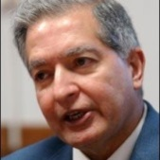
This year, awards announcements were made prior to the Assembly meeting. Here is a summary of those awards given:
Ronald A. Shellow Award - Established in 2004 in honor of Ronald A. Shellow, M.D., past Speaker of the Assembly, this award recognizes departing members of the Assembly who have served the Assembly far beyond the general standards of service shown by most members of the Assembly. For 2019, the award was presented to Charles Price, MD (Area 7). For 2020, the award was presented to Bhasker Dave, MD (Area 4) and Robert Cabaj (Area 6) (posthumously).
Assembly Award for Excellence in Service and Advocacy - Established in 2011, this award recognizes activities by women that promote mental health and reduce stigma related to psychiatric illness, particularly on behalf of women and members of disadvantaged population groups. The award was presented to Jemima Kankam, MD (Area 3)
Assembly Resident-Fellow Member Mentor Awards were presented to Jessica Isom, MD, MPH (Area 1), Cristina Secarea, MD (Area 3), Stephen Salzbrenner, MD (Area 4), Anish Dube, MD, MPH (Area 6), Ray Hsiao, MD (Area 7), Jose Vito, MD (Area 2), Eugene Lee, MD (Area 5)
District Branch Best Practice Award: Colorado Psychiatric Society and New York County Psychiatric Society
Assembly Award for the District Branch and Area Council with the Highest Percentage of Voting: Mid-Hudson Psychiatric Society (34%) and Area 2 Council (23%)

Commendations and Farewells
Commendations to Speaker Paul O’Leary, MD and the APA Assembly Staff for their amazing work in transitioning our complex Assembly meeting agenda to an online virtual format. Farewells to all those going off the Assembly after this meeting, and thank you for your dedication and tireless service.

Assembled Virtual Moments *
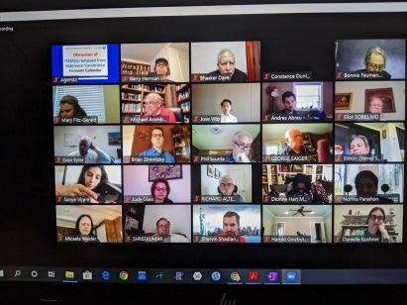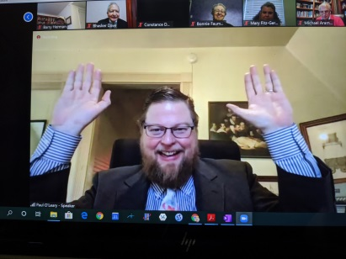

Future Meetings
All future governance and business meetings of the APA will be conducted virtually for the remainder of 2020. Announcements regarding dates and Action Paper deadlines for the November Assembly will be forthcoming.

